Stepwise Multiple Regression

Management Report

Based on analysis of our store data, we found that our daily average revenue is most affected by the number of TV ads produced and run per year, as well as the average in-store traffic count per day. We also found that for each additional ad produced and run per year, the average daily in-store traffic for that year increases by 144 customers and the average daily revenue per year increases by $1585.94.

The following are factors that have a significant impact on average daily revenue:

* Number of TV ads produced and run per year
* Average daily in-store traffic

An action plan based on these factors would be:

* Increase the number of TV ads produced per year.
  + The average daily in-store traffic is correlated to the number of TV ads that are produced per year. Each TV ad produced results in an increase of 144 to the daily average in-store traffic.

The following are factors that **do not** have a significant effect on average daily revenue:

* Number of customer complaints per day
* Number of marketing campaigns per year
* Number of end of aisle displays
* Number of employees
* Number of coupons and printed ads

Recommendations

Each of the factors can be handled by:

* Number of customer complaints per day - Customer complaints do not have a large effect on profit and should mostly be handled on a case to case basis. Complaints should still be handled to keep up the good image of the brand but should not be a priority.
* Number of marketing campaigns per year - Your current marketing campaigns are not working and are not bringing in profit. Try marketing items that are specified to your local population or demographic. With this, you should be expecting to make $250 per marketing campaign.
* Number of end of aisle displays - End of aisle displays are not being sold to the correct brands that make the store significant profit. Try putting brands on the end of the aisle that directly make the stores more money. With this, you should be expecting to make $100 per end of the aisle display.
* Number of employees - The current number of employees that the stores have is optimal and no employee should be fired or hired.
* Number of coupons and printed ads - Coupons and printed ads are not being used to their fullest potential. Try making coupons for different items or offering more of a discount. With this, you should be expecting to make $10 per coupon or printed ad.

Action Plan

How much would it cost to implement the recommendations and why do they cost that?

* There should not be any action from customer complaints as they have little to no effect on profit.
* Making more directed marketing campaigns should cost around 5000 over current yearly budget as the same campaigns can be run just with different products and items.
* Selling end of aisle displays to more profitable companies should not cost the stores any extra cost.
* Hiring a new employee would lose you money and firing one of your current employees is not guaranteed to add profit.
* Coupons and printed ads offering different items or discount amounts would cost around $3-4 more per Coupon or printed ad.

Cost/Revenue Priority

Compare the costs from the action plan to the revenue generated to the upper 95% value (highest payback per variable).

Implementing all of the suggested changes would cost around $6000-$7000 which means that 5 more TV ads would need to be run to pay for the changes but the changes would make the company up to $10000 more per year.

1. Building a predictive model

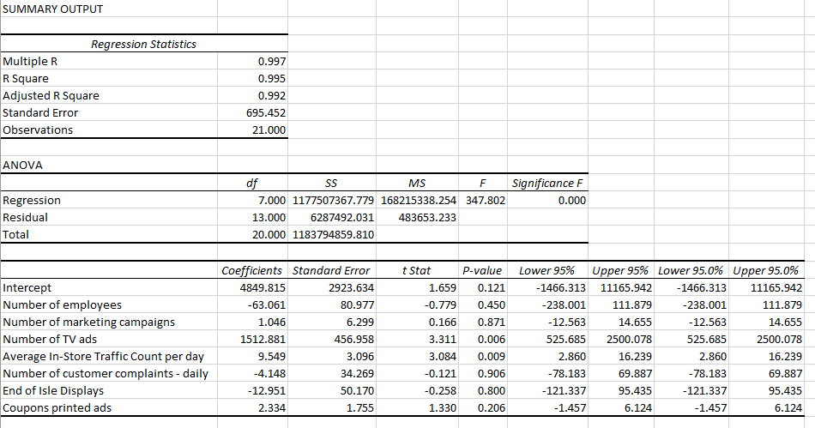

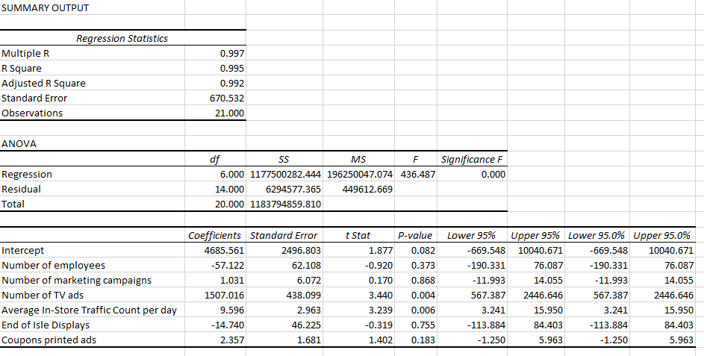

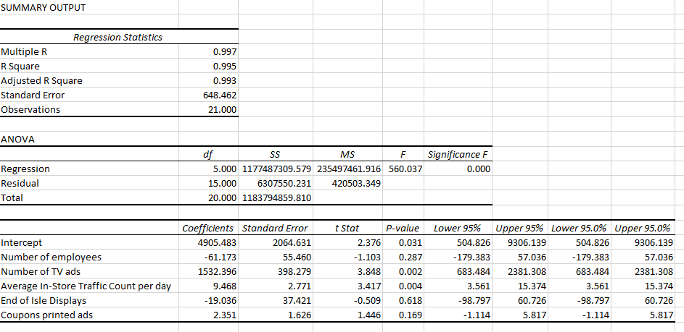

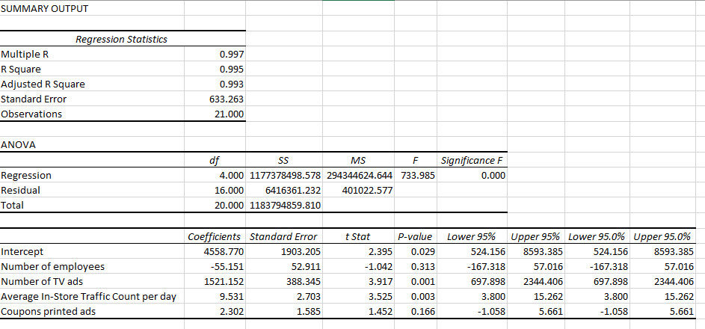

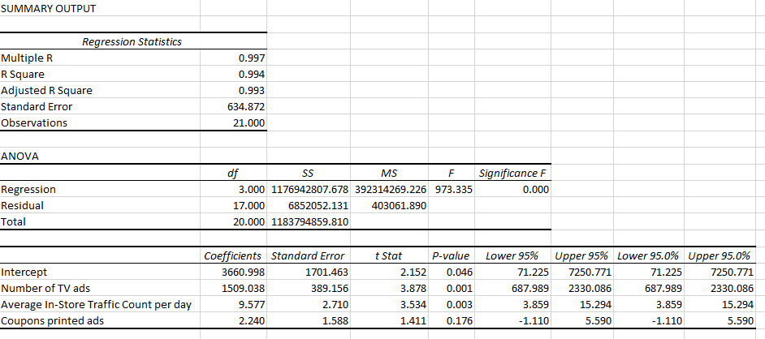

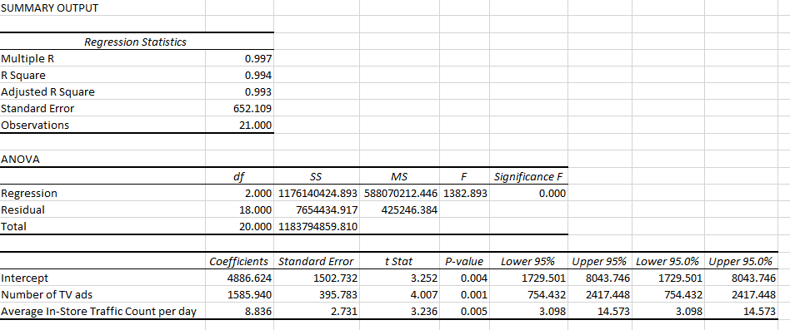

After running several rounds of regression statistics on the data set, and removing the data column with the lowest correlation to the *Average Daily Revenue*, the result are the *Number of TV ads* and *Average In-Store Traffic Count per day* which both have a p-value of below 0.01.   
We believe the reason that both of these variables are this high is because the *Average In-Store Traffic Count per day* is a result of the *Number of TV ads*. We can test this by performing regression based on the traffic per day.  
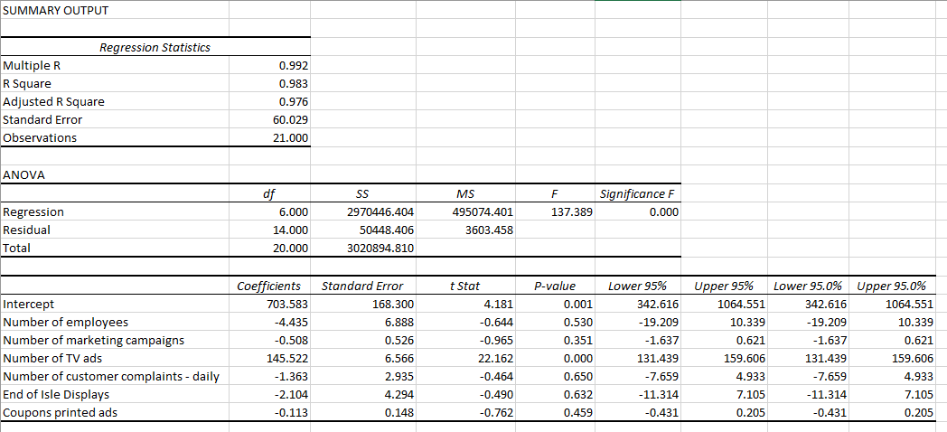  
The only p-value that shows any significant correlation is the *Number of TV ads*. Therefore the number of TV ads is responsible for the number of traffic in the store. This may be due to the store being local and the advertisements reaching the surrounding population. More TV ads would bring more attention to a local grocery store over existing large chains of grocery stores as the ads can be better targeted to the local population.